Chesterfield County Rural Water Co., Inc
PO Box 270
Chesterfield, SC 29709
843 623- 6090 FAX# 843 623- 6052

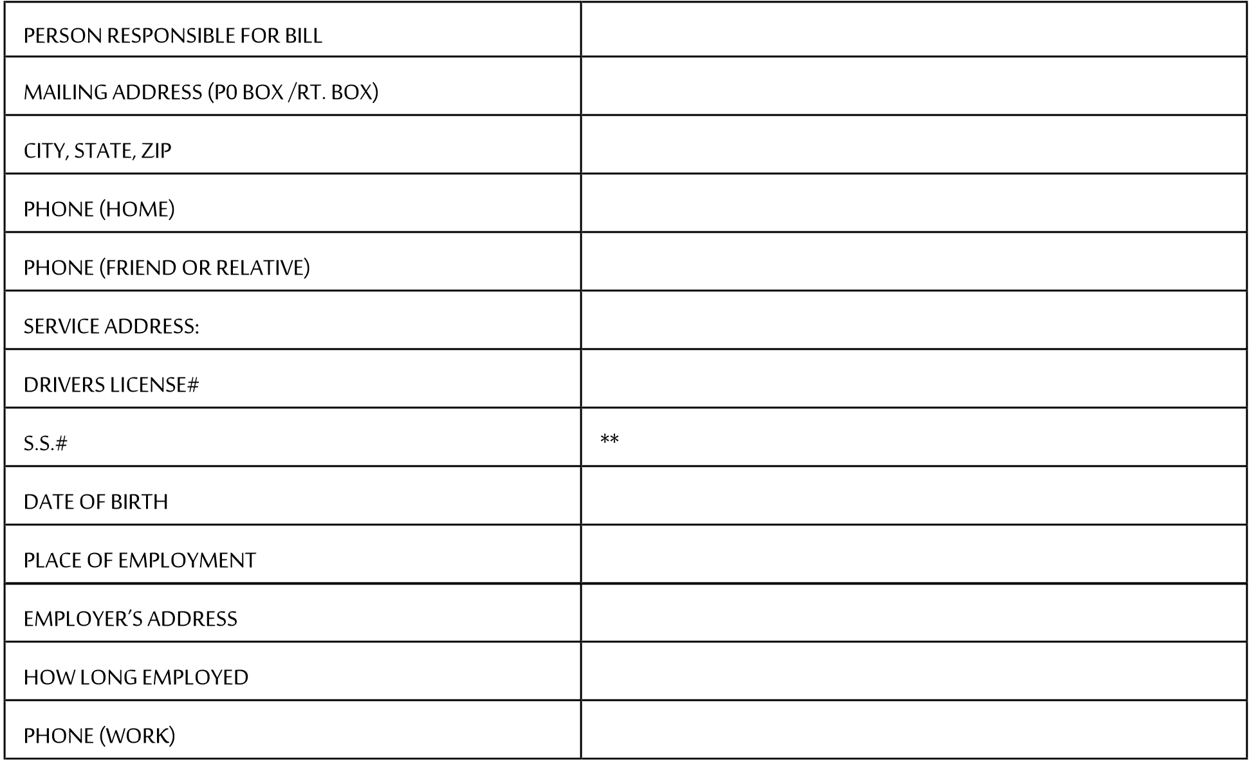

The following information is required by the USDA Office of Rural Development in accordance with Title VI, of the Code of Federal Regulations for data and information collection.

RACE: _____ NATIONAL ORIGIN: _________________________________________

I choose not to provide information with regard to race or national origin. _____

_______________________________________________________Initial_______
I CERTIFY THAT THE INFORMATION ABOVE IS TRUE AND CORRECT. I UNDERSTAND THAT I AM RESPONSIBLE FOR THE WATER USAGE ON THIS ACCOUNT UNTIL I REQUEST IN WRITING TO HAVE THE WATER SERVICE DISCONNECTED.

IF I CANNOT BE LOCATED WITHIN A REASONABLE PERIOD OF TIME TO RECEIVE THE REFUND OF MY DEPOSIT, I HEREBY REQUEST THAT MY METER DEPOSIT BE RETAINED BY CHESTERFIELD COUNTY RURAL WATER CO., INC., AND USED LOCALLY RATHER THAN BEING FORWARDED TO THE STATE OF SOUTH CAROLINA UNCLAIMED PROPERTY DIVISION.

SIGNED:X___________________________ DATE: _______________________

WITNESS: ________________________

**It is MANDATORY for all members of CCRWC to provide their Social Security number. Social Security numbers are required by this agency for potential use in the Setoff Debt/GEAR Collection program.

Chesterfield County Rural Water Company, Inc.
P0 Box 270
Chesterfield, SC 29709
843 623 6090
FAX# 843 623 6052

I, X_________________________________________, understand that I am responsible for and will be required to pay a minimum water bill of $18.00 each month for each 3/4" meter (or $27.00 for a 1" or larger meter) that I have installed. I understand that $9.00 is charged per thousand gallons of water used, in addition to the minimum water bill.

I understand that service calls that are requested by me are subject to a service call fee if the service call is determined to not be the fault of the water company. The current service fee schedule is $25.00 per call during normal business hours and $50.00 per call after hours. A service call is defined as any request for service by a member that requires a technician to respond to the members location (these include meter checks, leak checks, cutting off water in case of a leak, etc.)

I also understand after applying for a water meter tap it may take 10 working days to have the meter tap installed.

___________________________________
**MEMBER**

_________________________
DATE

WATER USERS AGREEMENT

This agreement entered into between the Chesterfield County Rural Water Company, Inc., a nonprofit corporation hereinafter called the “Association,” and X_____________________________________, member(s) of the Association hereinafter called “Member.”

WITNESSETH

Whereas, the member desires to purchase water from the Association and to enter into a water users agreement as required by the Bylaws of the Association.

NOW THEREFORE, in consideration of the mutual covenants, promises, and agreements herein contained, it is hereby understood and agreed by the parties hereto as follows:

The Association shall furnish, subject to the limitations set out in the Bylaws and Rules and Regulations now in force or as hereafter amended, such quantity of water as Member may desire in connection with Member’s occupancy of the following described property:

__________________________________________________________________________________________________________________________________________________________________________________________________________________________________________________________________

The Member agrees to grant to the Association, its successors and assigns, a perpetual easement in, over, under and upon the above-described land, with the right to erect, construct, install, and lay, and thereafter use, operate, inspect, repair, maintain, replace and remove water pipelines and appurtenant facilities, together with the right to utilize adjoining lands belonging to the member for the purpose of ingress to and egress from the above-described lands.

The Member shall install and maintain at the Member’s expense a service line which shall begin at the meter and extend to the dwelling or place of use. The service line shall connect with the distribution system of the Association at the nearest place of desired use by the Member, provided the Association has determined in advance that the system has sufficient capacity to permit delivery of water at that point.

The Member agrees to comply with and be bound by the Articles, Bylaws, Rules and Regulations of the Association, now in force, or as hereafter duly and legally supplemented, amended, or changed. The member also agrees to pay for water at such rates, time, and place as shall be determined by the Association, and agrees to the imposition of such penalties for noncompliance as are now set out in the Association's Bylaws and Rules and Regulations, or which may be hereafter adopted and imposed by the Association.

The Member agrees to pay a Tap Fee (¾” x 5/8” ) in the amount of $1,000.00. The Member agrees to pay a Meter Deposit in the amount of $150.00.

The Association shall purchase and install a cutoff valve and may also include a water meter in each service. The meter and cut-off valve assembly are the property of the Association. The Association shall have exclusive right to use such cutoff and water meter.

The Association shall have final authority in any question of location of any service line connection to its distribution system; shall determine the allocation of water to Members in the event of a water shortage; and may shut off water to a Member who allows a connection or extension to be made of the members service line for the purpose of supplying water to another user. In the event the total water supply shall be insufficient to meet all of the needs of the Members or in the event there is a shortage of water, the Association may prorate the water available among the various Members on such basis as is deemed

equitable by the Board of Directors, and may also prescribe a schedule of hours covering use of water for garden purposes by particular Members and require adherence thereto or prohibit the use of water for garden purposes, provided that, if at anytime the total water supply shall be insufficient to meet all of the needs of all of the Members, the Association must first satisfy all of the needs of all Members, for domestic purposes before supplying any water for livestock purposes and must satisfy all the needs of all Member for both domestic and livestock purposed before supplying any water for garden purposes.

The Member agrees that no other present or future source of water will be connected to any waterlines served by the Association's waterlines and will disconnect from the present water supply prior to connecting to and switching to the Association’s system and shall eliminate their present or future cross-connections in the member's system. The member shall not connect more than one residence or commercial building to any single meter. A separate meter is required for each residence.

To equally distribute certain fixed costs (Rural Development Debt Repayment) to all accounts, once service is established (ie. a meter is installed), a flat service fee is billed monthly. The flat service fee differs based on meter size. The flat service fee is to be paid on a monthly basis regardless of whether the meter is being used or not. If the user fee is not paid on a monthly basis and kept current, then prior to the meter being reactivated (water service restored), all past due monthly service fees or the current (at the time reactivation is requested) tap fee, whichever is less, shall be paid in full , plus a reconnect fee.

Property owners are responsible for monthly charges on all vacant rental or lease property. In the event an outstanding balance is owed on rental or lease property, the property owner is responsible for paying any and all outstanding fees and unpaid balances before the water service will be restored to the property.

The Member shall connect the service lines to the Association’s distribution system and shall commence to use water from the system on the date the water is made available to the Member by the Association. Water charges to the Member shall commence on the date service is made available, regardless of whether the Member connects to the system.

The failure of a customer to pay water charges duly imposed shall result in the automatic imposition of the following penalties.

- Nonpayment within ten days from the due date will be subject to a penalty of 10%.

- Nonpayment within thirty days from the due date will result in the water being shut off from the customer’s property.

- In the event it becomes necessary for the Association to shut off the water from a Member’s property, a fee set by the corporation in its rate schedule will be charged for reconnection of the service.

IN WITNESS WHEREOF, we have executed this agreement this _____ day of _________________, 2018.

CHESTERFIELD COUNTY RURAL WATER CO. INC.

By:______________________________________________

XX___________________________________________
**MEMBER**

- THIS INSTITUTION IS AN EQUAL OPPORTUNITY PROVIDER -

